Bayesian Confidence Layer

It maintains a trust score called a prior, for each AI model per task type. After every query, the Evaluation Layer returns a score for each model's response. The Confidence Engine uses Bayes Theorem to update the prior using that score. The updated value becomes the new prior for the next query.

This loop runs after every single query, making the system continuously smarter about which models to trust for which tasks over time.

Evaluation Layer => [CONFIDENCE ENGINE] => Fusion Engine.
The confidence engine sits between scoring and response blending.
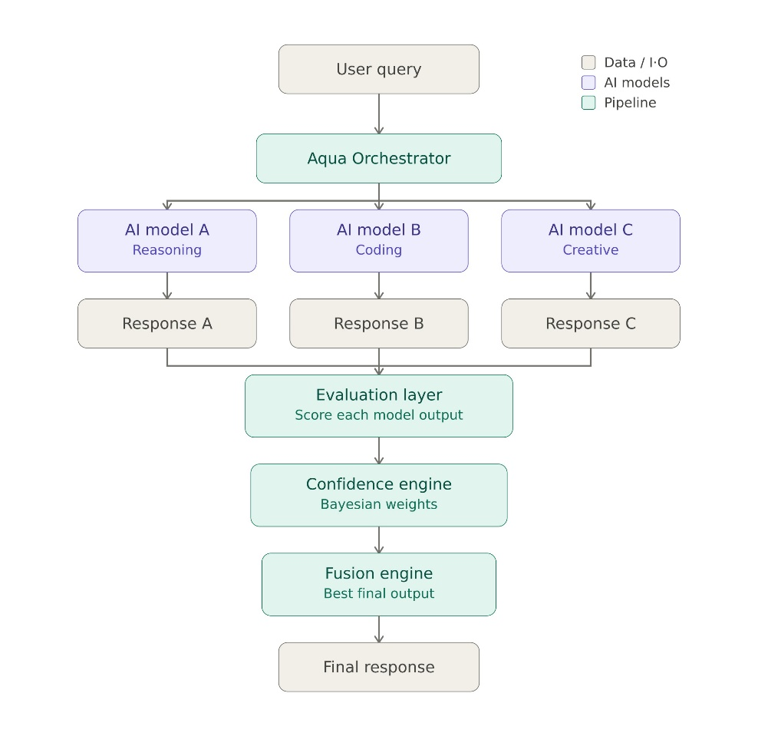

Bayesian Formula:
P(mi | oi) = P(oi | mi) x P(mi) / P(oi)

Where,
P(mi) = Prior, the model’s current trust score before this query (can be called historical reliability)
P(oi | mi) = Likelihood, the score this model just received from the evaluation layer
P(oi) = Normaliser, makes all the model weight sum = 1 (used during fusion engine time)
P(mi | oi) = Posterior, the updated trust score (becomes the new prior for next query)

Example:
Three models respond to a reasoning query. Evaluation Layer returns scores:

Model | Prior | Eval Score | Raw Posterior (prior x e.score) | Normalised Weight
Model A | 0.72 | 0.91 | 0.655 | 0.655 / 1.163 = 0.563
Model B | 0.45 | 0.63 | 0.284 | 0.284 / 1.163 = 0.244
Model C | 0.58 | 0.38 | 0.220 | 0.220 / 1.163 = 0.189
 |  |  | 1.163 (= evidence) | 1.000

Highest Trust Score: Model A (gets 56.3% weight in the final answer)

Learning Rate
If for example there is one bad query due to some reasons, then it should not destroy the model’s prior (which was the historical trust). So we can use a learning rate alpha α to blend the old prior and new posterior (new updated trust).
New prior = (1 - α) × old prior + α × posterior

Points to be noted:
- Using this formula we are also preventing a single bad response from crashing the model’s prior.
- Also, it fixes the vulnerability in your regular bayes theorem. And model’s trust score will not instantly drop to zero.

α Value | Effect | For our usage
0.1 | Very slow, takes around 20 queries to meaningfully shift a prior | Too slow for v1
0.2 | Moderate, one bad query moves prior by at most 20% of the gap | USE for v1
0.3 | Fast, adapts quickly but more volatile | Use if models are actively being swapped

Trying alpha = 0.2
Example: Model A prior = 0.72. One bad query (score = 0).
With α=0.2: new prior = 0.8×0.72 + 0.2×0.0 = 0.576.
A 20% drop and collapse prevented.
Model will not shut down or give wrong responses.

3. Data Structure

Schema
The confidence store is a nested dictionary: tasktype → model id → record. Every model starts at 0.5

{
"reasoning": {
"model a": {
"prior": 0.72, current trust score
"query count": 14, total queries evaluated
"update history": [ last 50 updates
{
"query id": "q_014",
"eval score": 0.88,
"old prior": 0.70,
"new prior": 0.72,
}
]
},
"model b": { ... },
"model c": { ... }
},
"coding": { ... },
"creative": { ... },
"general": { ... }
}

Design Decisions

Initial prior= 0.5

Prior floor= 0.05, Prior ceiling= 0.95

4. Update Logic
Step | Operation | Detail
1 | Get current prior | Retrieve store[task_type][model_id]['prior']
2 | Compute raw posterior | posterior = eval_score × prior
3 | Clamp posterior | Keep in range [0.05, 0.95]
4 | Apply learning rate | damped = (1-α) × prior + α × posterior
5 | Save new prior | store[task_type][model_id]['prior'] = new_prior
6 | Log to history | Append {eval_score, old_prior, new_prior, }}

5. Persistence Layer Recommendation
Option | v1? | v2?
In-memory Python dict | Yes, zero setup, instant | No, lost on restart
JSON file backup | Yes, remains across restarts | No, not concurrent-safe
Redis | Overkill for v1 | Yes, fast, shared, persistent
PostgreSQL | Too heavy | Possible if relational data needed

For v1, we will only save and load in json

6. Design Questions

- Where do priors live?
Python dict (v1) with json file backup. swap to redis in v2 with a little code change

- How often do they update?
After every single query real-time continuous learning. Batching adds latency and complexity for no gain at this scale.

- Initial prior for a new model with no history?
0.5, because it does not have any evidence so there should not be any bias for a new model and the system will start completely neutral.

- How to prevent one bad response crashing a prior?
Learning rate α=0.2 dampens each update. Floor of 0.05

- How to prevent one model dominating permanently?
Ceiling of 0.95 ensures no model can completely throw out others responses

- How do you handle a new task type not in the list?
Auto-initialize all models at 0.5 for the new task type

